System Requirements Documentation

Car Rental System

Author: Justin Verrick

Date: 3/12/2025

Table of Contents:

1. Introduction
2. Customer Problem Statement
3. System requirements
4. Functional Requirements Specifications
5. System Sequence Diagram
6. Activity Diagram
7. User Interface Specification
8. Project Plan
9. Reference

1. Introduction:

The Car Rental System is a Flask-based web application that lets users register, log in, reserve vehicles, make a payment, and modify and cancel their reservation. Admin users can add, update, and remove vehicles, modify pricing, and see customer reservations.

2. Customer Problem Statement:

Car rental businesses face challenges with manual reservations, payment tracking, and vehicle availability management. This system provides a centralized platform where users can easily reserve vehicles, admins can manage inventory and set vehicle pricing, and the system automates reservation tracking and payment processing.

3. System Requirements:

3.1 Hardware Requirements

* Processor: Intel core i3 equivalent or higher
* RAM: 4GB minimum
* Storage: At least 500MB free space
* Internet Connection: Required for hosting and database management

3.2 Software Requirements

* Operating System: Windows 10/11, macOS, or Linux
* Backend: Flask (Python 3.6+)
* Database: SQLite
* Frontend: HTML, CSS (Jinja Templates)
* Tools: Github, VS Code

3.3 Non-Functional Requirements

* Security: User authentication and secure password storage using Werkzeug Security
* Scalability: The system should be able to handle multiple reservations at once
* Usability: Simple and intuitive UI for both users and admins
* Performance: Response time for queries should not exceed 3 seconds

4. Functional Requirement Specification:

|  |  |  |
| --- | --- | --- |
| **No.** | **Priority Weight** | **Description** |
| REQ-1 | High | Users/Admins can register, log-in, and manage their profiles. |
| REQ-2 | High | Users can browse available vehicles. One type of vehicle per vehicle type (sedan, SUV, Van, and truck). |
| REQ-3 | High | Users can make a reservation for a vehicle. |
| REQ-4 | High | Users can make secure payments. |
| REQ-5 | High | Users can cancel or modify their reservations. |
| REQ-6 | High | Admins can manage vehicle inventory by adding, modifying, and deleting vehicles. Admins can modify or set vehicle price point. |
| REQ-7 | High | Administrators can view all user’s reservations. |
| REQ-8 | Medium | The car rental system needs to send emails confirming reservation and payments. |
| REQ-9 | Medium | Notification system that can update users on the status or their reservation. |

5. System Sequence Diagram:

Sequence Diagram for reserving a vehicle

Actor: Customer

Objects: Car Rental System, Vehicle Inventory

Steps for reserving a vehicle:

1. The customer selects a vehicle option for rental (sedan, SUV, van, or truck).
2. The system confirms vehicle selected availability.
3. If the vehicle is available, the system will let the customer enter rental dates and select the type of vehicle they want.
4. The system calculates the rental cost.
5. The customer checks the rental selected and then goes to checkout.

The sequence diagram is shown below:

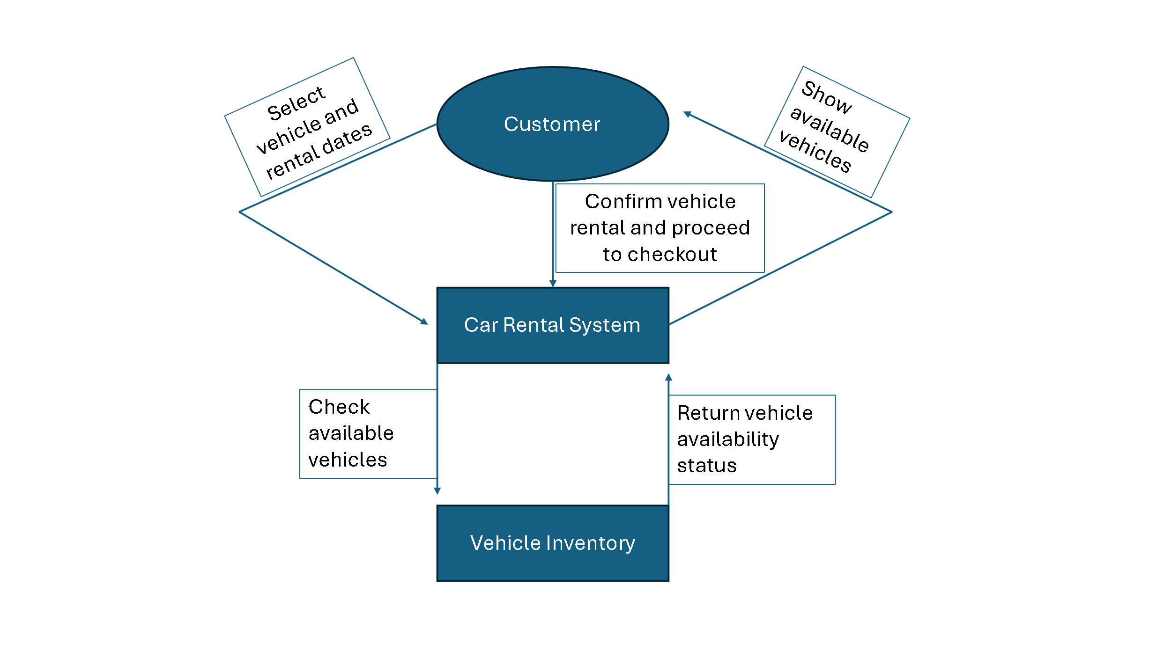

Sequence Diagram for processing customer credit card payments

Actor: Customer

Objects: Payment, Credit Card

Steps for processing credit cards:

1. Customer enters their credit card information.
2. The payment system receives credit card information from customers.
3. The webpage will show customer reservation with “paid” next to it.
4. If the credit card is verified, the customer receives a payment confirmation.
5. If the credit card is denied, the customer receives an error message.

The sequence diagram is shown below:

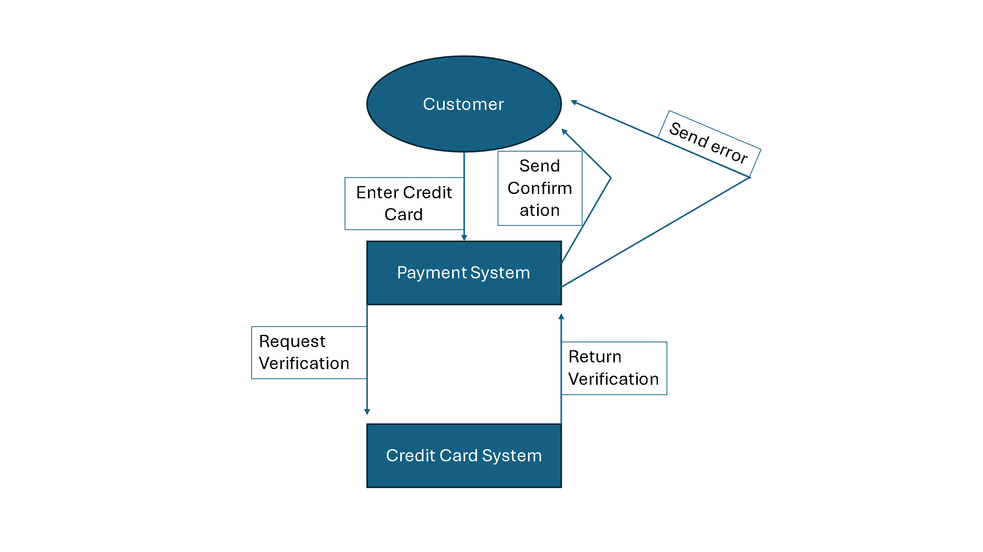

6. Activity Diagram:

Activity Diagram for customer payment process

States:

* Initial State: The customer begins the payment process.
* Final State: The customer receives confirmation for the reserved vehicle.

Actions:

The payment process starts when the customer enters and confirms their license. If the system approves the license, the customer then will verify their reservation. If their reservation is correct, the customer then will enter their payment information. Then the system will process the transaction. If the customer’s credit card is approved, then the system will create confirmation and remove the vehicle from the vehicle inventory. If the customer’s credit card is denied, an error message is displayed to the customer. If at any point the customer’s license or reservation is invalid, the system will decline the customer’s request and inform them.

Activity Diagram is shown below:

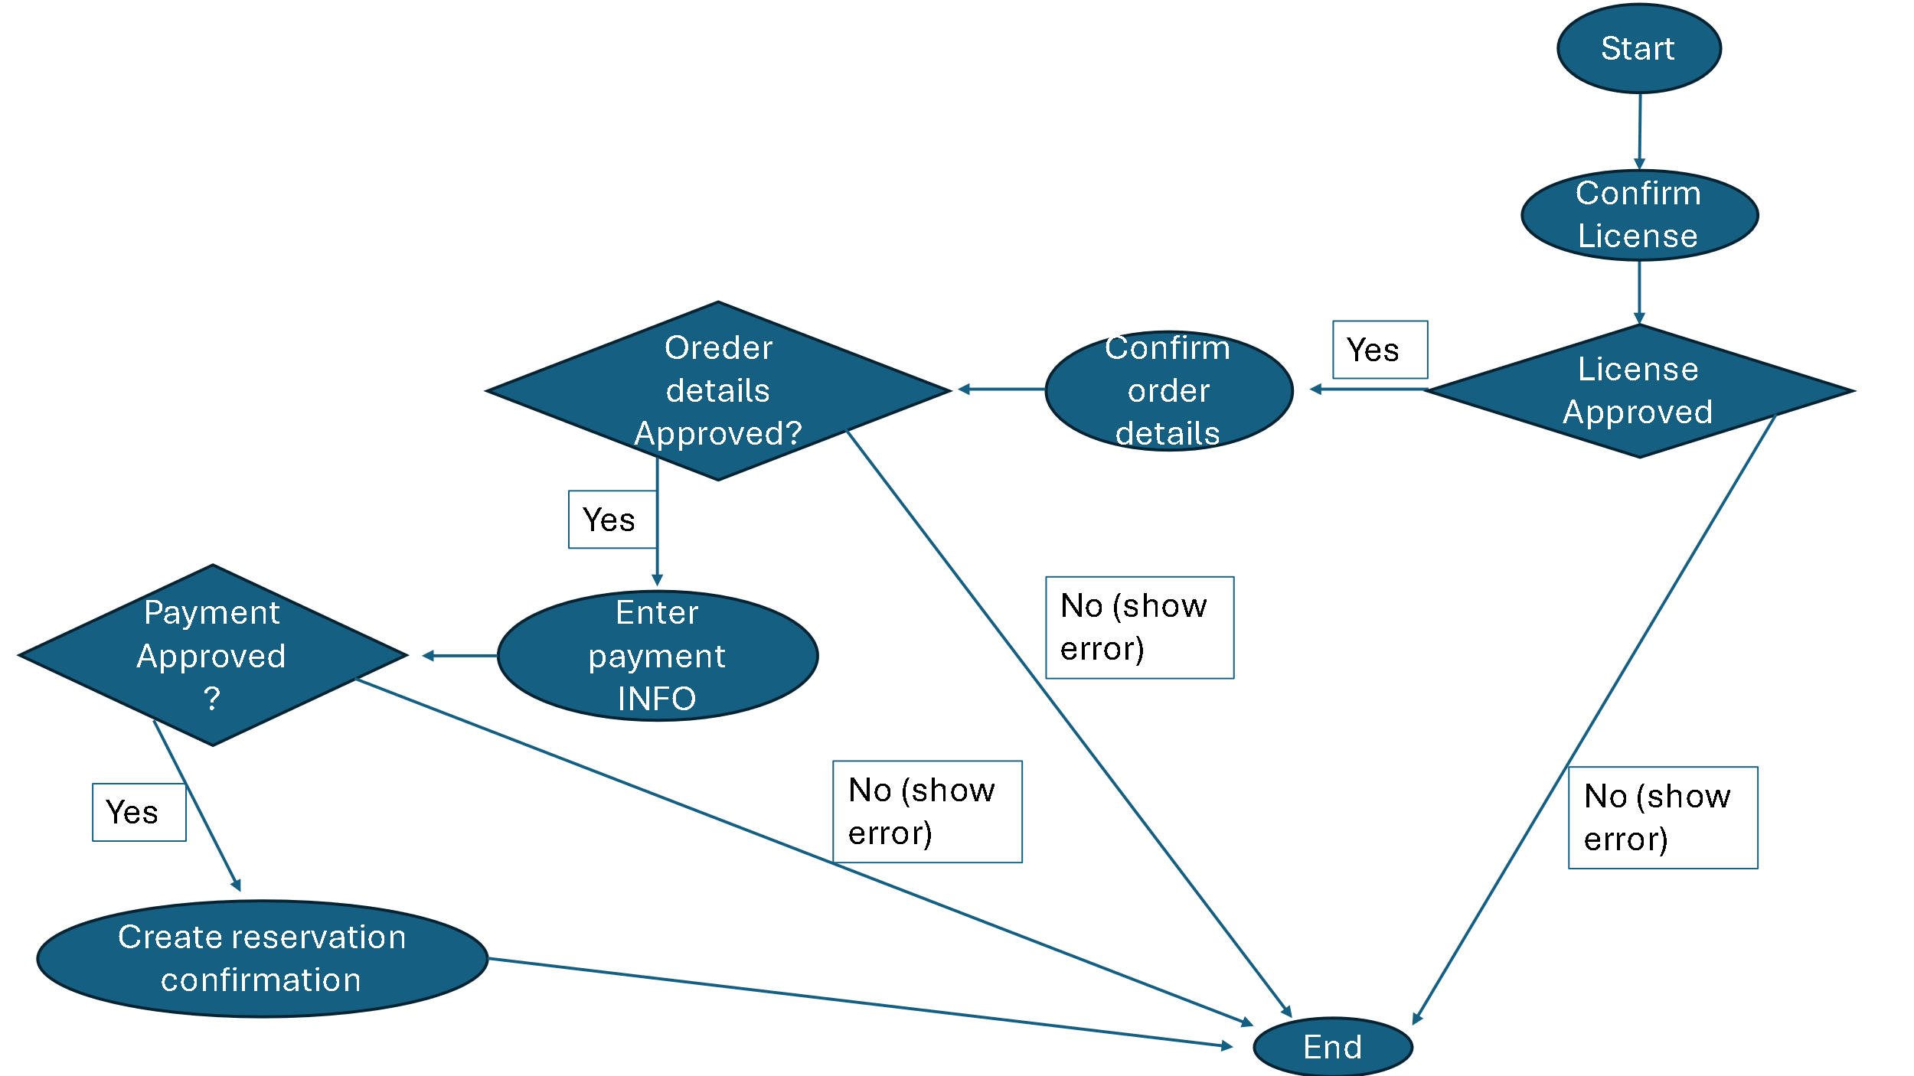

Activity Diagram for reserving a vehicle

States:

* Initial State: Customer requests to rent a vehicle.
* Final State: Customer confirms the rental and proceeds to checkout.

Actions:

Customer will request to rent a vehicle, then they will select the rental dates and choose a vehicle type (sedan, SUV, truck). The system will check vehicle availability and show the customer’s available vehicle. If the selected vehicle is available to reserve, the system will calculate the total price for the rental. If the customer confirms the rental, they will go to checkout. If the vehicle selected is unavailable to reserve, the system will notify the customer and allow them to select a different vehicle from the inventory.

Activity Diagram shown below:

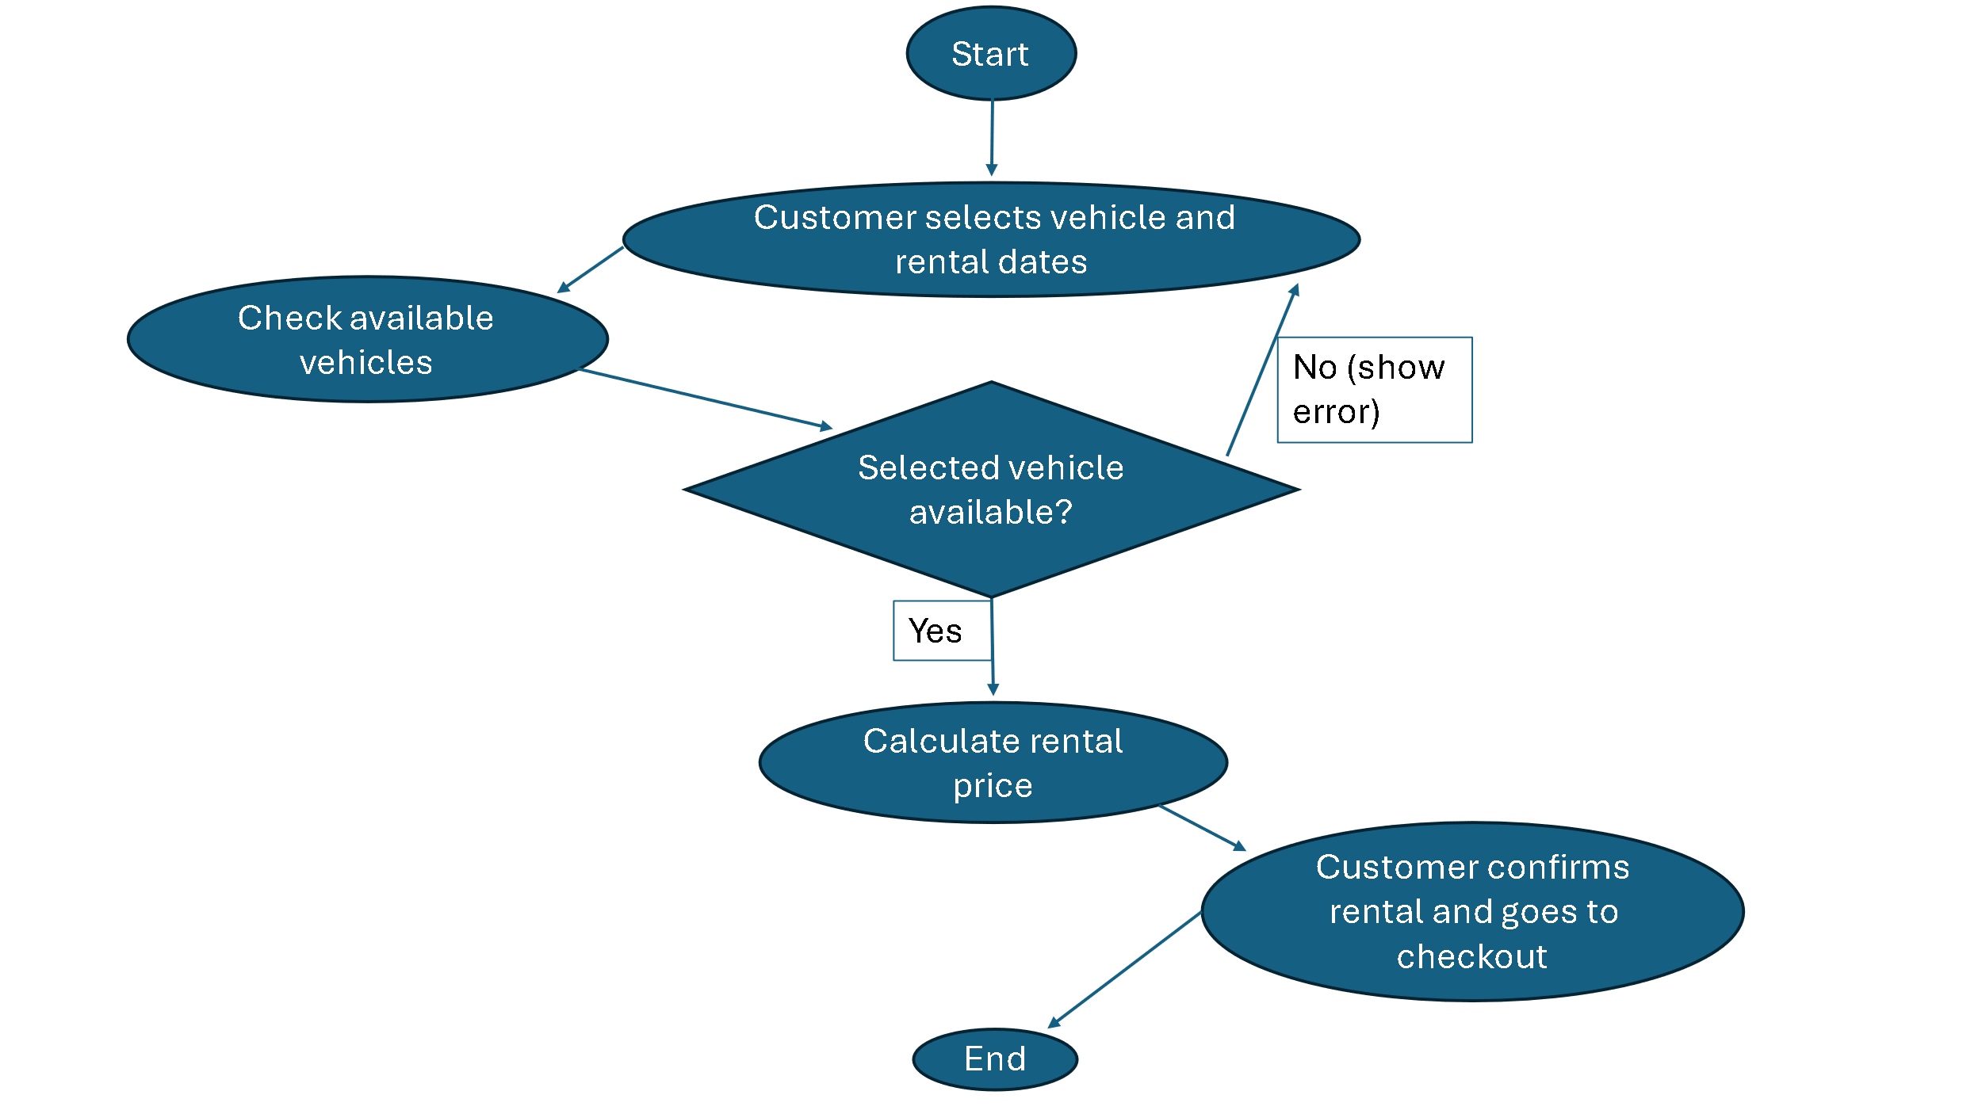

7. User Interface Specification:

**Preliminary Design:**

The User Interface for the Car Rental System lets users navigate through core functionalities such as vehicle selection, reservation management, payment processing, and administrative functions. Below is selected use cases and their respective interface specifications. At the login page, if an administrator logs in, it will take them directly to the administrative page.

**Registration and Login:**

How Users Enter Information: If the user doesn’t have an account, they select to Register. This will take user to another page to register. Users will enter their details into input fields Username and Password. After filling out the information, users click the "Register" button. If users already have an account, they enter username and password and click "Login."

Website Homepage:

Website Register Page:

Website Login Page:

**Navigation Path:**

Login > Register > Homepage > Login

**User Effort Estimation:**

Clicks: 3 for logging in with an account already. 8 if the user needs to register first.

Keystrokes: 10-30, entering username and password.

**Vehicle Selection Page:**

How Users Enter Information: Users select a vehicle by clicking the highlighted Reserve text next to Sedan, SUV, Van, or Truck. Rental price per day is next to the vehicle type.

**Navigation Path:**

Login > Vehicle selection > reserve > Confirm reservation

**User Effort Estimation:**

Clicks: 6

Keystrokes: None

**Payment Processing Page:**

How Users Enter Information: Users enter payment details including card number, expiration date, CVV, and name on card. Clicking "Confirm Payment" submits the transaction.

**Navigation Path:**

Login > vehicle selection > reserve > Confirm Payment

**User Effort Estimation:**

Clicks: 6, Select Card Number, Expiration Date, CVV, Name on Card. Then clicking Confirm Payment.

Keystrokes: 20-40, entering user information for card number, expiration date, CVV, and name on card.

**Administration Dashboard:**

How Users Enter Information: Administrators can add, remove, or modify vehicles and vehicles price points by entering details in the appropriate fields and clicking action buttons. When administrators log in from the homepage, it will take the user straight to the administration dashboard.

**Navigation Path:**

Login > administration dashboard

**User Effort Estimation:**

Clicks: 5, Adding a new vehicle, price, and removing a vehicle.

Keystrokes: 10-20, Entering vehicle type and price per day.

8. Project Plan:

**w1 – 2: Set up environment and framework**

* Select and install the tools and frameworks needed for project: Python, Flask, SQLite, HTML, CSS, and JavaScript.
* Set up the folder structure for the project and create basic files (index.html, main.py, etc.).
* Establish the connection between the frontend and backend.
* Configure the SQLite database and design the structure of the database to store user data, vehicle details, and reservations.

**w3 – 5: Build the user registration, user login,**

* Create the user register and login function.
* Allow users to register, login, and manage their profiles and vehicle reservations.
* Ensure user data is secure.
* Set up the dashboard for users to view available vehicles and allow them to make a vehicle reservation.

**w6 – 7: Develop administrator functions for managing vehicle inventory and customer reservations**

* Create an admin login and dashboard.
* Create functions for administrators to add, edit, or delete vehicle models in the inventory.
* Create Function for administrators to set and modify vehicle price point.
* Build features to manage reservations.

**w8: Test and fix, record demo for midterm.**

* Test the user registration, login, and profile management system for errors.
* Test the administrator function of managing vehicle inventory.
* Record a demo showing features of the car rental system for the mid-term.

**w7 - 13: Improve the system based on customer and administrator feedback**

* Based on feedback; improve features, fix bugs, and improve user experience.
* Create a notification system for users to receive updates on reservation status.
* Apply additional features for administrators to modify or cancel user reservations.

**w14-15: Final testing and record demo for final presentation**

* Perform final testing to confirm all features are working (user authentication, reservation system, administrator functions, payment processing).
* Clean up the user interface for a better professional look.
* Make the user interface more appealing to the user.
* Record a demo of the system for the final presentation.

9. Reference:

GitHub Repository: <https://github.com/JDV1281/Car-Rental-System>